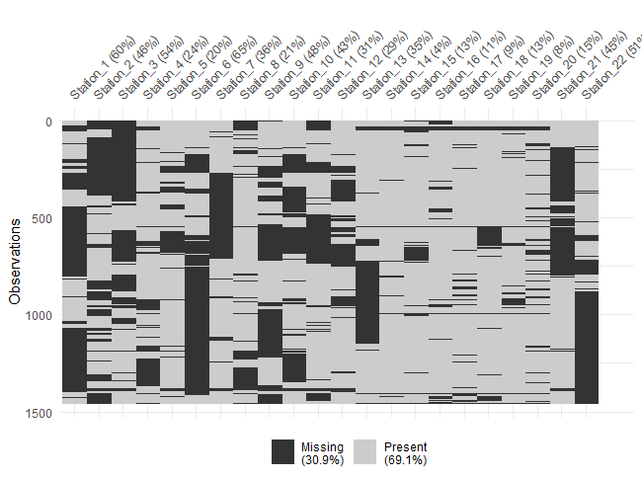

Figure 1: percentage of missing values for PM2.5 in 22 Mashhad air quality stations from 2017 to 2020.

Table1: Comparison of performance of KNN and Random Forest methods for missing data imputation

|  |  |  |  |
| --- | --- | --- | --- |
| Station | Model | MAE | RMSE |
| 1 | KNN | 5.97 | 9.05 |
| Random Forest | 4.99 | 7.83 |
| 2 | KNN | 12.32 | 36.61 |
| Random Forest | 10.59 | 34.35 |
| 3 | KNN | 12.90 | 24.66 |
| Random Forest | 10.12 | 20.14 |
| 4 | KNN | 6.61 | 11.01 |
| Random Forest | 5.71 | 9.81 |
| 5 | KNN | 10.13 | 27.89 |
| Random Forest | 9.25 | 27.11 |
| 6 | KNN | 10.34 | 34.99 |
| Random Forest | 11.16 | 28.10 |
| 7 | KNN | 7.64 | 14.99 |
| Random Forest | 6.28 | 13.92 |
| 8 | KNN | 5.65 | 7.95 |
| Random Forest | 5.08 | 7.61 |
| 9 | KNN | 11.55 | 24.21 |
| Random Forest | 10.68 | 20.20 |
| 10 | KNN | 8.96 | 25.65 |
| Random Forest | 8.93 | 26.60 |
| 11 | KNN | 18.03 | 40.01 |
| Random Forest | 14.23 | 37.78 |
| 12 | KNN | 18.67 | 40.73 |
| Random Forest | 15.18 | 37.87 |
| 13 | KNN | 19.32 | 35.13 |
| Random Forest | 16.13 | 27.72 |
| 14 | KNN | 5.21 | 8.90 |
| Random Forest | 4.19 | 7.60 |
| 15 | KNN | 5.85 | 10.36 |
| Random Forest | 5.69 | 9.68 |
| 16 | KNN | 5.98 | 13.91 |
| Random Forest | 5.05 | 12.73 |
| 17 | KNN | 4.11 | 5.63 |
| Random Forest | 3.29 | 4.61 |
| 18 | KNN | 6.20 | 9.99 |
| Random Forest | 4.56 | 8.11 |
| 19 | KNN | 6.19 | 10.11 |
| Random Forest | 5.21 | 7.85 |
| 20 | KNN | 8.59 | 14.72 |
| Random Forest | 7.78 | 13.77 |
| 21 | KNN | 7.28 | 12.52 |
| Random Forest | 7.02 | 11.98 |
| 22 | KNN | 8.23 | 23.28 |
| Random Forest | 5.71 | 11.48 |

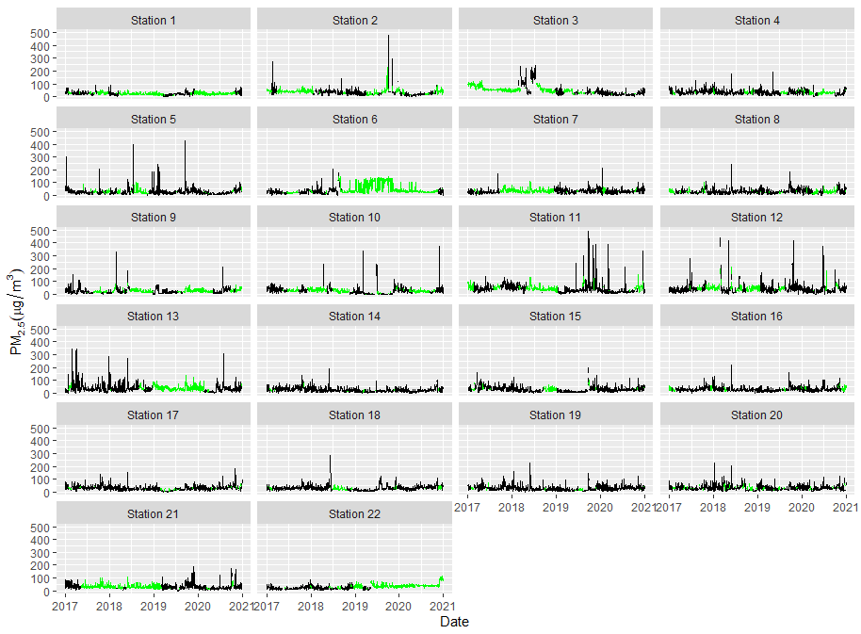

Figure 2: Daily concentration of PM2.5 after estimating missing values (light green lines) using random forest method.



Figure 3: Natural spline with 7 degree of freedom for time trend.

Table2: The parameter estimation for spatial DLNM covariates

|  |  |  |  |  |
| --- | --- | --- | --- | --- |
| **Variable** | | **Estimate** | **Std. Error** | **P-value** |
| **Health screening program** | | 0.457 | 0.038 | <0.001 |
| **Covid-19 pandemic** | | -0.479 | 0.065 | <0.001 |
| **Holiday** | | -0.318 | 0.024 | <0.001 |
| **Day of week\*** | |  |  |  |
|  | Saturday | 0.401 | 0.019 | <0.001 |
|  | Sunday | 0.367 | 0.020 | <0.001 |
|  | Monday | 0.389 | 0.019 | <0.001 |
|  | Tuesday | 0.384 | 0.020 | <0.001 |
|  | Wednesday | 0.352 | 0.020 | <0.001 |
|  | Thursday | 0.273 | 0.021 | <0.001 |

*Friday is the weekend